EXPERIMENT 9

nano pract9.c

Code -

#include <stdio.h>
int main(){
int pages[]={7,0,1,2,0,3,0,4};
int frames[3];
int i,j,k,flag,faults=0;
for(i=0;i<3;i++)frames[i]=-1;
printf("FIFO Page Replacement\n");
int index=0;
for(i=0;i<8;i++){
flag=0;
for(j=0;j<3;j++){
if(frames[j]==pages[i]){
flag=1;
break;
}
}
if(flag==0){
frames[index]=pages[i];
index=(index+1)%3;
faults++;
}
printf("Page %d -> ",pages[i]);
for(j=0;j<3;j++)printf("%d ",frames[j]);
printf("\n");
}
printf("Total Page Faults = %d\n\n",faults);

printf("LRU Page Replacement\n");
faults=0;
int time[3],counter=0;
for(i=0;i<3;i++){
frames[i]=-1;
time[i]=0;
}
for(i=0;i<8;i++){
flag=0;
for(j=0;j<3;j++){
if(frames[j]==pages[i]){
counter++;
time[j]=counter;
flag=1;
break;
}
}
if(flag==0){
int min=0;
for(j=1;j<3;j++)
if(time[j]<time[min])min=j;
frames[min]=pages[i];
counter++;
time[min]=counter;
faults++;
}
printf("Page %d -> ",pages[i]);
for(j=0;j<3;j++)printf("%d ",frames[j]);
printf("\n");
}
printf("Total Page Faults = %d\n\n",faults);

printf("Optimal Page Replacement\n");
faults=0;
for(i=0;i<3;i++)frames[i]=-1;
for(i=0;i<8;i++){
flag=0;
for(j=0;j<3;j++){
if(frames[j]==pages[i]){
flag=1;
break;
}
}
if(flag==0){
int pos=-1,farthest=i;
for(j=0;j<3;j++){
int found=0;
for(k=i+1;k<8;k++){
if(frames[j]==pages[k]){
if(k>farthest){
farthest=k;
pos=j;
}
found=1;
break;
}
}
if(!found){
pos=j;
break;
}
}
if(pos==-1)pos=0;
frames[pos]=pages[i];
faults++;
}
printf("Page %d -> ",pages[i]);
for(j=0;j<3;j++)printf("%d ",frames[j]);
printf("\n");
}
printf("Total Page Faults = %d\n",faults);
return 0;
}

Output -
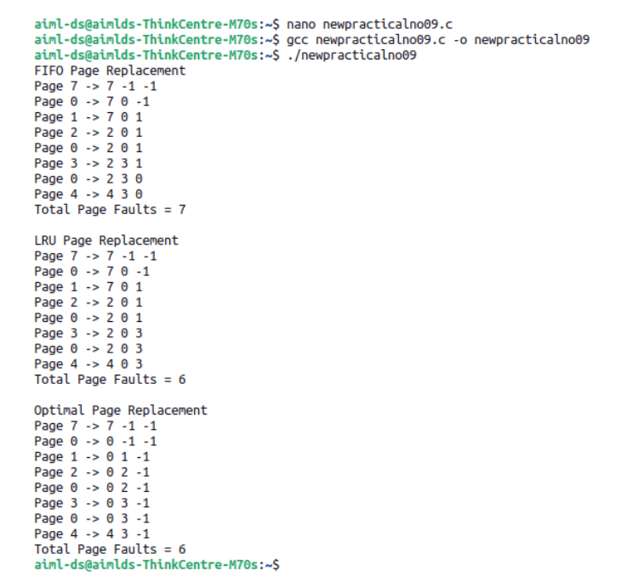

AIM
Write a program in C to demonstrate the concept of page replacement policies such
as FIFO, LRU and Optimal.
RESOURCES REQUIRED
Ubuntu Operating System
Terminal
Text Editor (nano)
GCC Compiler

THEORY
n Operating Systems, when a process needs a page that is not currently in memory, a
page fault occurs. To handle this situation, the operating system must bring the
required page from secondary memory into main memory. If the memory frames are full,
the system must replace an existing page using a Page Replacement Algorithm.
The goal of page replacement algorithms is to reduce the number of page faults and
improve system performance.
1. FIFO (First In First Out)
In the FIFO algorithm, the page that entered memory first is replaced first.
Advantages
Simple to understand and implement.
Disadvantages
May remove frequently used pages.
2. LRU (Least Recently Used)
In the LRU algorithm, the page that has not been used for the longest time is
replaced.
Advantages
Better performance compared to FIFO.
Disadvantages

Requires tracking page usage history.
3. Optimal Page Replacement
In the Optimal algorithm, the page that will not be used for the longest time in the
future is replaced.
Advantages
Produces the minimum number of page faults.
Disadvantages
Future page references are not known in real systems, so it is mostly used for
theoretical comparison.
These algorithms help in efficient memory management and reduce the impact of
page faults.

CONCLUSION
Thus, the program to demonstrate FIFO, LRU and Optimal page replacement
algorithms for handling page faults was successfully executed. The Optimal
algorithm produced the minimum number of page faults compared to FIFO and
LRU, showing more efficient memory utilization.

